Project Design Phase-II
Data Flow Diagram & User Stories

Date | 19 Febraury 2026
Team ID | LTVIP2026TMIDS41894
Project Name | Plugging into the Future: An Exploration of Electricity Consumption Patterns Using Tableau
Maximum Marks | 4 Marks

Data Flow Diagrams:
A Data Flow Diagram (DFD) is a traditional visual representation of the information flows within a system. A neat and clear DFD can depict the right amount of the system requirement graphically. It shows how data enters and leaves the system, what changes the information, and where data is stored.
Example: DFD Level 0 (Industry Standard)

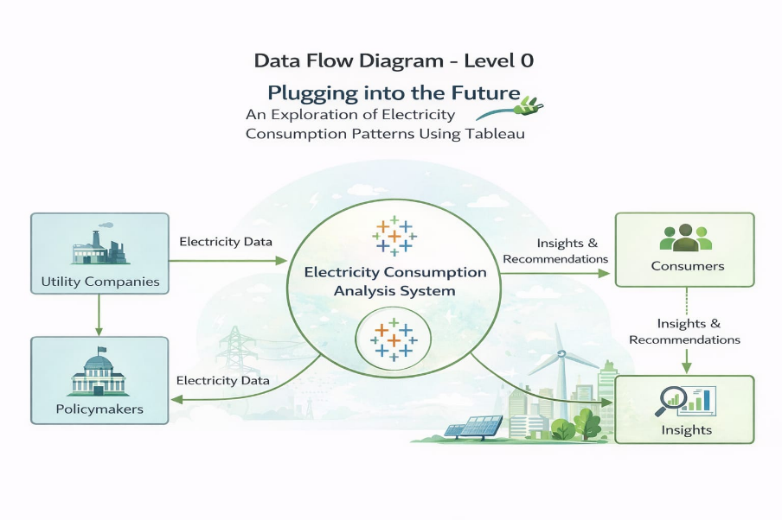
User Stories
User stories describe the system from the user’s point of view by clearly stating what the user wants to achieve and why. They help convert user needs into functional requirements and guide the design of dashboards and features in the project.
User Type | Functional Requirement (Epic) | User Story No | User Story / Task | Acceptance Criteria | Priority | Release
Customer (Mobile user) | Registration | USN-1 | As a user, I can register by entering email, password and confirm password | I can access my account/dashboard | High | Sprint-1
Customer (Mobile user) | Registration | USN-2 | As a user, I receive confirmation email after registration | I receive confirmation email & click confirm | High | Sprint-1
Customer (Mobile user) | Registration | USN-3 | As a user, I can register using Facebook | I can register & access dashboard with Facebook login | Low | Sprint-2
Customer (Mobile user) | Registration | USN-4 | As a user, I can register using Gmail | I can register & access dashboard using Gmail login | Medium | Sprint-1
Customer (Mobile user) | Login | USN-5 | As a user, I can log in using email & password | Dashboard opens successfully after login | High | Sprint-1
Customer (Mobile user) | Dashboard | USN-6 | As a user, I can reset my password if I forget it | Password reset link is sent to registered email | High | Sprint-1
Customer (Web user) | Dashboard | USN-7 | As a web user, I can view total electricity consumption | Total consumption visualization is displayed | High | Sprint-1
Customer (Web user) | Dashboard | USN-8 | As a web user, I can compare 2019 and 2020 consumption | Comparison chart is displayed correctly | High | Sprint-1
Customer (Web user) | Dashboard | USN-9 | As a web user, I can filter consumption data by region | Region filter updates dashboard | High | Sprint-2
Customer (Web user) | Analysis | USN-11 | As a web user, I can analyze time-of-day usage patterns | Peak & off-peak charts are shown | High | Sprint-2
Customer (Web user) | Analysis | USN-12 | As a web user, I can analyze seasonal variations | Seasonal trend visualization displayed | High | Sprint-2
Customer (Web user) | Analysis | USN-13 | As a web user, I can analyze sector-wise consumption | Sector-wise dashboard is displayed | High | Sprint-2
Customer (Web user) | Reports | USN-14 | As a web user, I can download reports | Report downloads in PDF/Excel format | Medium | Sprint-3
Customer Care Executive | Support | USN-15 | As a support executive, I can view user queries | User query list is visible | Medium | Sprint-2
Customer Care Executive | Support | USN-16 | As a support executive, I can respond to user issues | Response is sent successfully | Medium | Sprint-2
Customer Care Executive | Monitoring | USN-17 | As a support executive, I can view dashboard usage issues | Issue report is generated | Low | Sprint-3
Administrator | Data Management | USN-18 | As an admin, I can upload electricity datasets | Dataset uploads successfully | High | Sprint-1
Administrator | Data Management | USN-19 | As an admin, I can update yearly consumption data | Updated data reflects in dashboard | High | Sprint-2
Administrator | User Management | USN-20 | As an admin, I can manage user accounts | Admin can activate/deactivate users | Medium | Sprint-2
Administrator | Analytics | USN-21 | As an admin, I can monitor system usage statistics | Usage report is generated | Low | Sprint-3
Administrator | Security | USN-22 | As an admin, I can manage system access permissions | Role-based access works properly | Medium | Sprint-2

